**Lab 2 Summary**

**Phoebe Madsen and Austin Long**

* 1. We downloaded the 5 years of data, see spread sheet
  2. We calculated the Log returns for each day in the five year period, we then calculated the daily volatility by using the formula $\sqrt{.97×{0.015}^{2}+.03×r_{t}^{2}}$. We started by assuming the last day in 2006 had a daily volatility of .15. We calculated this so that we could get an accurate estimate of the daily volatility starting in 2008. We then multiplied the daily volatility by 2.33 to get the one day VaR.
  3. In part B, we multiplied the one day VaR by the square root of 10 to get the 10-day VaR. The problem is that you are assuming the volatility across the 10 days is going to be constant and is going to be the same. This problem is called stationarity and the computing the Log returns does not in fact fix it. This problem can be fixed by using very advanced statistical manipulation; however, you would have to go through a lot of trouble to correct this problem. There wouldn’t be a huge change in your answer if you were to fix this problem, especially because you are computing a 10-day VaR. The discrepancy would be a lot bigger if calculating a larger time period VaR.
  4. 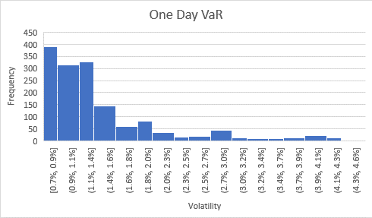

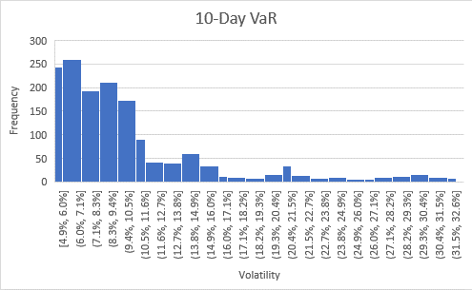

|  |  |
| --- | --- |
| *10-Day VaR* | |
|  |  |
| Mean | 0.107406 |
| Standard Error | 0.001674 |
| Median | 0.089564 |
| Mode | #N/A |
| Standard Deviation | 0.059381 |
| Sample Variance | 0.003526 |
| Kurtosis | 2.758267 |
| Skewness | 1.775545 |
| Range | 0.276959 |
| Minimum | 0.049319 |
| Maximum | 0.326278 |
| Sum | 135.2238 |
| Count | 1259 |

|  |  |
| --- | --- |
| *One-Day VaR* | |
|  |  |
| Mean | 0.014577 |
| Standard Error | 0.000227 |
| Median | 0.012156 |
| Mode | #N/A |
| Standard Deviation | 0.008059 |
| Sample Variance | 6.5E-05 |
| Kurtosis | 2.758267 |
| Skewness | 1.775545 |
| Range | 0.037589 |
| Minimum | 0.006694 |
| Maximum | 0.044282 |
| Sum | 18.35258 |
| Count | 1259 |
|  |  |

2.

* 1. We divided the log returns by the daily volatility of the day before
  2. There were 1259 data points. In order to get the 1st percentile, we sorted the normalized return data and multiplied the 12th data point by.41 and added that to the 13th data point multiplied by .59 because the first percentile is 12.59. We got the first percentile to be -2.98. We then multiplied the daily volatility by -2.98 to get our nonparametric estimation for one day VaR.
  3. Our nonparametric estimations are slightly larger day by day. This means that we have a fat-tailed distribution.
  4. The one day VaR that we obtained in class assuming stationarity was 5.09%. Our nonparametric estimations are larger than the VaR we obtained in class from mid sept 2008- late July 2009 and from September-December of 2011. In 2008/2009 our nonparametric VaR is larger because in class we assumed stationarity while in part b we took into account the large, non-constant volatility in 2008/2009 due to the financial crisis. Similarly, 2011 had large volatility days which made our nonparametric VaR greater than the VaR we calculated in class that assumed stationarity.

1. Summary: In his article, “The Fourth Quadrant,” Nassim Taleb argues that statistics can and does fool many people; he writes about the limit of statistics and statistical analysis. There is a clear distinction to be made between true statisticians and people who use statistical tools and models. He argues that the “blind” users of statistical models are very important people in our society—financial institutional risk managers etc. He notes that their mis use of stats has led to financial crises such as the subprime loan crisis in 2008. He argues that there are two types of decision making (simple and complex) and two types of “randomness” (Mediocristan and extremistan). The fourth quadrant, where black swans happen, is the complex, extremistan quadrant. He argues that it is in this quadrant that stats has reached its limit. He argues that the rarer the event, the more data/ theory you need. So as events become rarer, you need a larger and larger sample over a larger and larger time period—usually to the magnitude that is impossible for us to obtain. Furthermore, past rare events do not predict future rare events. He argues that there is no “typical” in black swan events. In summary, Taleb is arguing that there events in the fourth quadrant cannot be predicted and or estimated, and therefore we can only analyze them once they have happened. However, he presents some simple guidelines to help “live” in the fourth quadrant. Generally speaking his guidelines are to avoid conventional stats models and methods and avoid prediction, and to understand that fourth quadrants events are atypical, take a lot of time to be revealed. He also warns people to not confuse the absence of volatility with the absence of risk.

Would more frequent data mitigate any of his criticisms?: He states in his article that much larger sample sizes are necessary for rarer events, so yes. However, he argues that the sample size necessary to precisely predict/ estimate fourth quadrant events is not possible to obtain.

Would a longer sample be helpful for coming up with a distribution for rare events?: Very similar to the answer above. The longer the time period, the better the estimate of the distribution for rare events, however, you would need such a long time period that is it no applicable in the real world.

Or is VaR just a waste of time to compute? VaR is not a total waste of time. Even though your estimate is not going to be good because you cannot predict black swan events, it is helpful to know how much of your portfolio is at risk given the extent of our statistical models. We should be cautious when using VaR and we should understand its limitations, but it is not a total waste of time.